# Basic AWARE Functionality with Standard CPRS

**All of AWARES Basic Functionality is available using the Standard CPRS Icon.**

* The AWARE Alert Viewer is available on the CPRS Tools Menu.

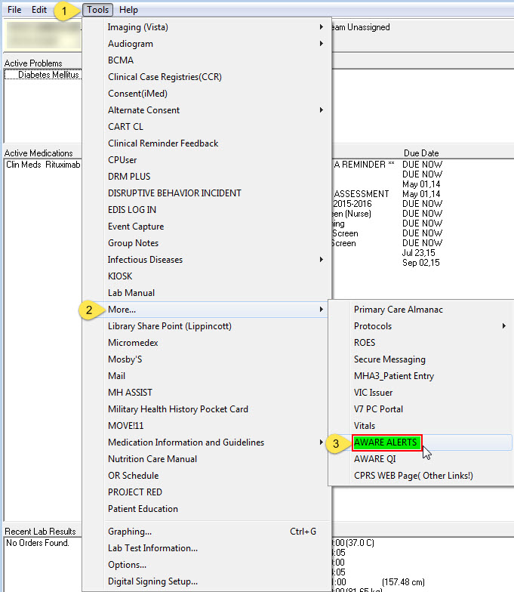

* Provides can access the AWARE Reminder Dialogs from the Shared Templates folder.

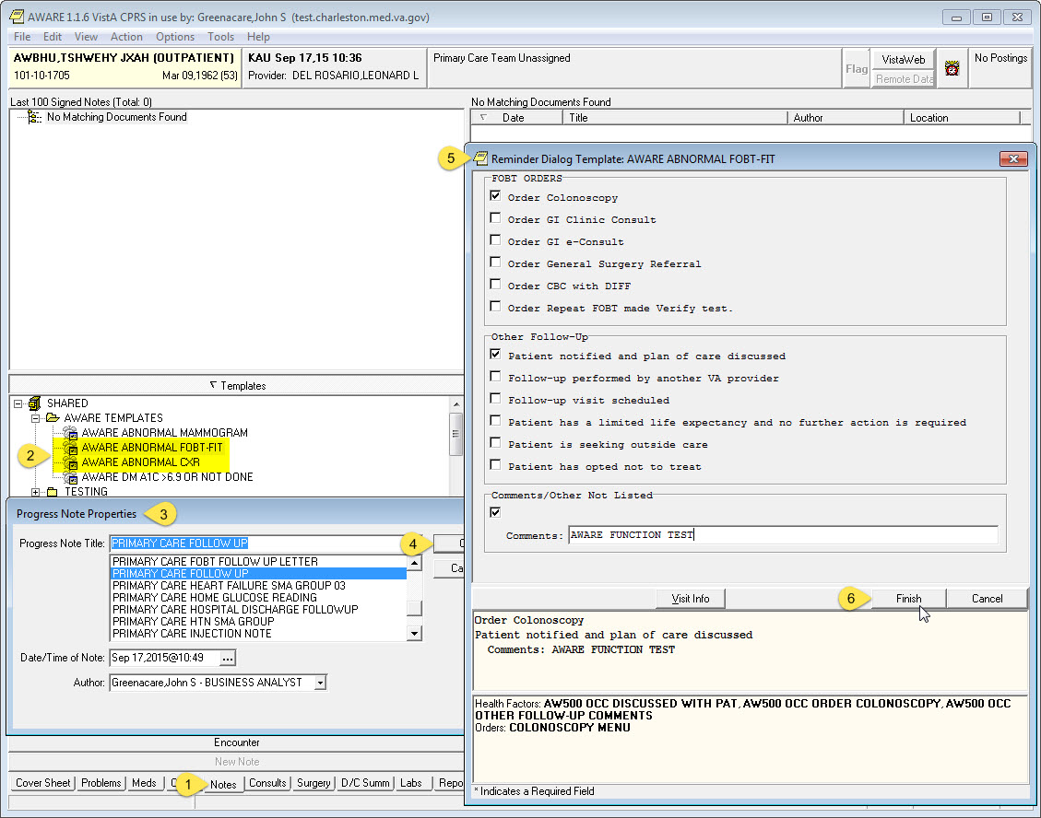

* Provides do not have to use the AWARE Reminder Dialogs to receive a positive Follow-Up Action.
  + Below is a screen shot of the AWARE Alert Viewer accessed from Standard CPRS.
  + The three highlighted AWARE Alerts received Positive Follow-Up actions based on Orders and/or Consults entered by the Providers.

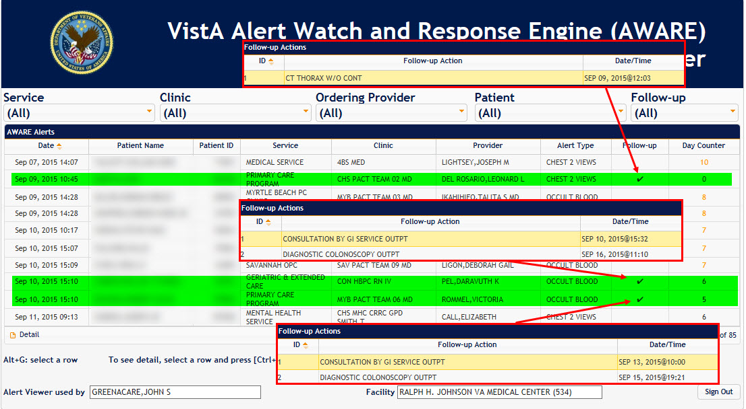

* Currently the majority of positive Follow-Ups are done using standard CPRS.
* AWARE Alerts are being tracked across all the Charleston Facilities.
* Any Provider will get a positive Follow-Up if they enter a Order and/or a Consult that has been setup in the AWARE Knowledge Based Editor. Below are the Orders and Consults that have been setup at Charleston.

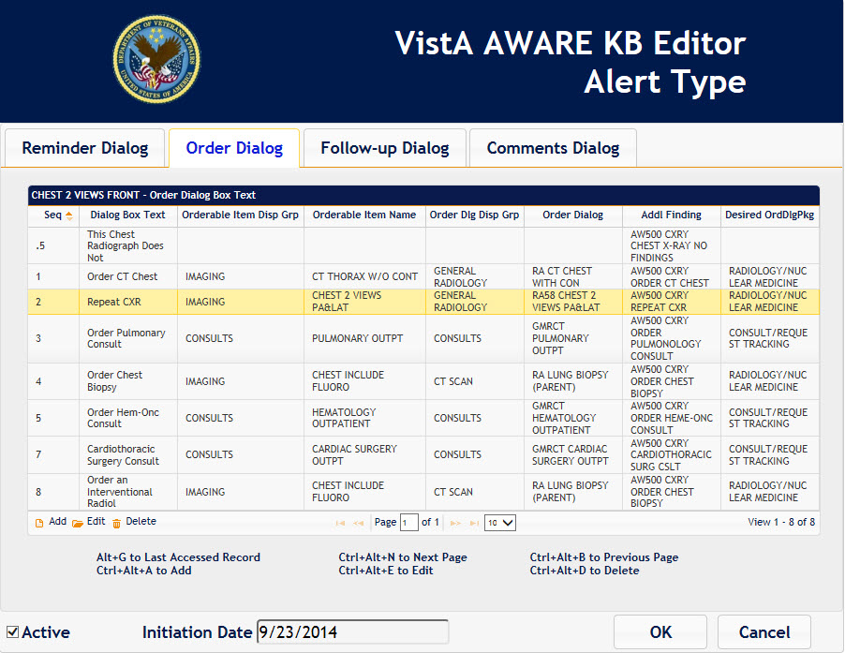

**The CPRS-Aware Icon only adds an Alert Pop-Up when the Patients chart is closed.**

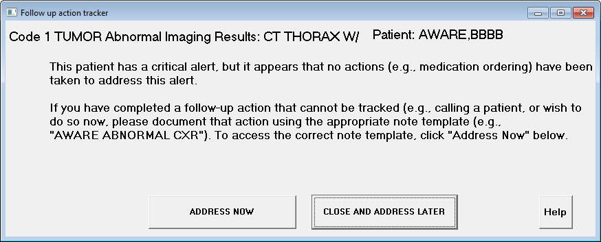

Recommend that Charleston document the standard Provider workflow process for Abnormal Occult Blood Lab results and Abnormal Chest Imaging results.

This will allow us to verify that AWARE has been correctly configured to capture the maximum number of Follow-Up actions and give us insight on how AWARE can be enhanced to provide the best care for the VA Patients.